CURRICULAM VITAE
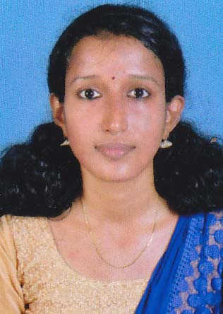
SRUTHI P V
NADUVILE VEETIL
ERAMAM P O
PAYYANUR
KANNUR-KERALA
PIN:670307
Mob:8289831550
EMAIL : sruthipv1991@gmail.com

CAREER OBJECTIVE

Intend to develop a career in a positive, progressive and high-tech corporate environment, which will help me to realize my full potential while giving me an opportunity to contribute my best to the organization. To work as challenging & responsible executive in your organization and grow within the organization.

PROFESSIONAL QUALIFICATIONS

Sl.N | Name of the Course | Board/University
1 | SSLC | Board of Kerala
2 | PLUS TWO | Board of Kerala
3 | D-Pharm | Directorate of Medical education Kerala

CCC CORE STRENGTH

- Optimistic, hardworking and mature personality with good interpersonal skills.

- Willingness to learn and a good team facilitator.

- Willingness to meet challenges and ability to overcome problems.

COMPUTER PROFICIENCY

- BASIC OPERATIOS OF COMPUTER
- MS OFFICE

PERSONAL DETAILS & REFERENCE

Father’s Name : N V SREEDHARAN

Mother’s Name : P V PREETHA

Date of Birth : 02/02/1991

Sex : Female

Religion : Hindu

Nationality : Indian

Marital Status : Single

Languages Known : English, Hindi & Malayalam

WORK EXPERIENCE

Worked as Pharmacist in Anil medicals, Mathamangalam.09/03/2012 to 31/01/2014

Worked as Pharmacist in Priyadarshini Hospital, Payyanur.18/02/2014 to 31/07/2016
DECLARATION

I hereby declare that the above written particulars are true to the best of my knowledge. Assuring utmost faithfulness and dedication in work assigned, if selected.

PLACE: BANGLORE
DATE : 6/10/2016 SRUTHI P V

